Lets start the Kotak API Algo Trading

1. All the steps and the simple word document code is available on Github https://github.com/RaigadTechnology/Kotak_API_Demo
2. Go to <https://tradeapi.kotaksecurities.com>
3. Register your login

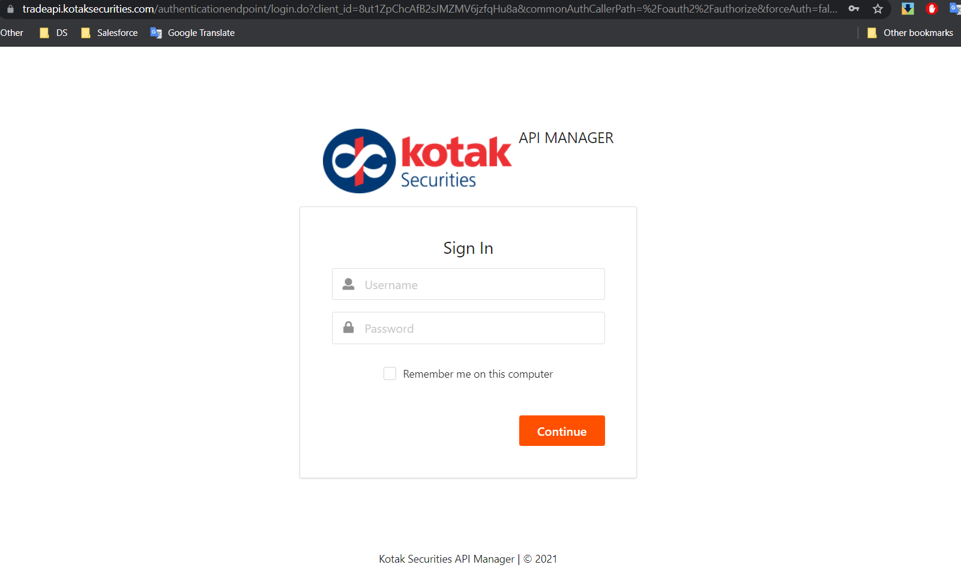

1. You will receive an user name (same as trading password) , password is different (remember this cant be change or there is no option of forgot password), also App ID via Email withing 10 to 30 min
2. Keep these 3 things handy and store securely as we need these in future.
3. Login with your user name and password
4. 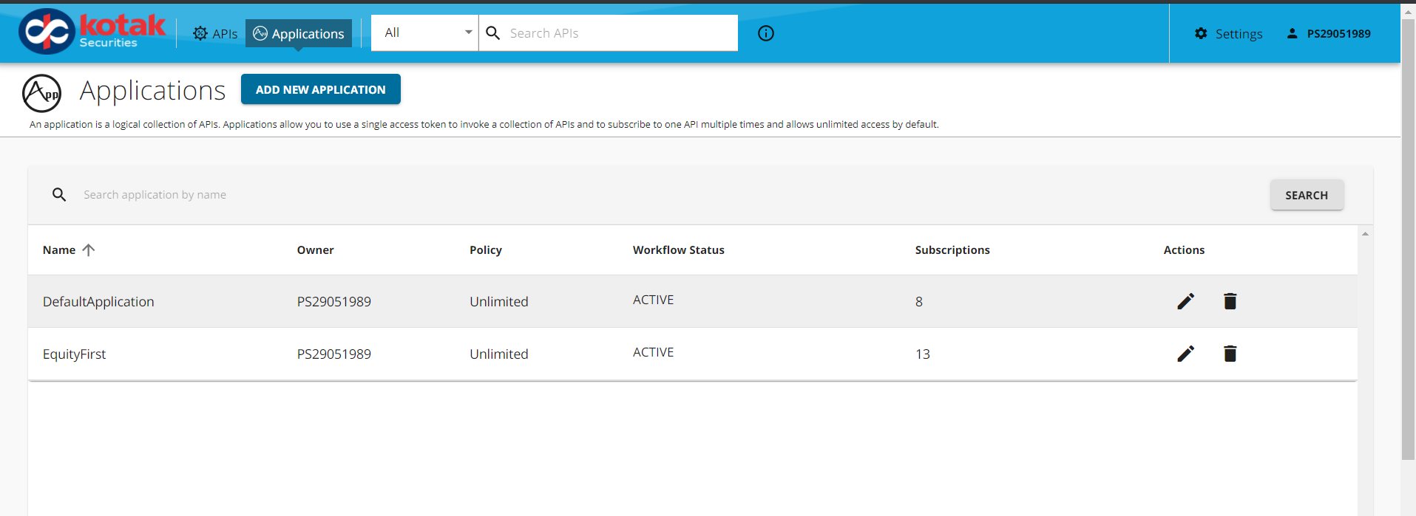
5. You will land up on this page
6. Create an API as show in Video
7. 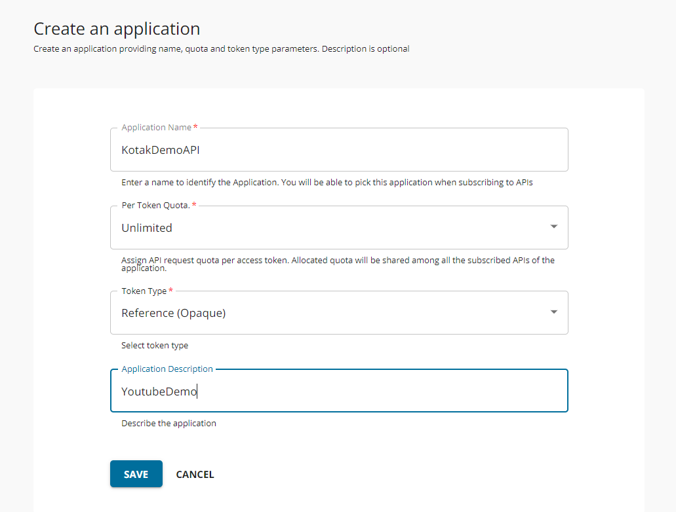
8. Next step is link your API with system APIs
9. 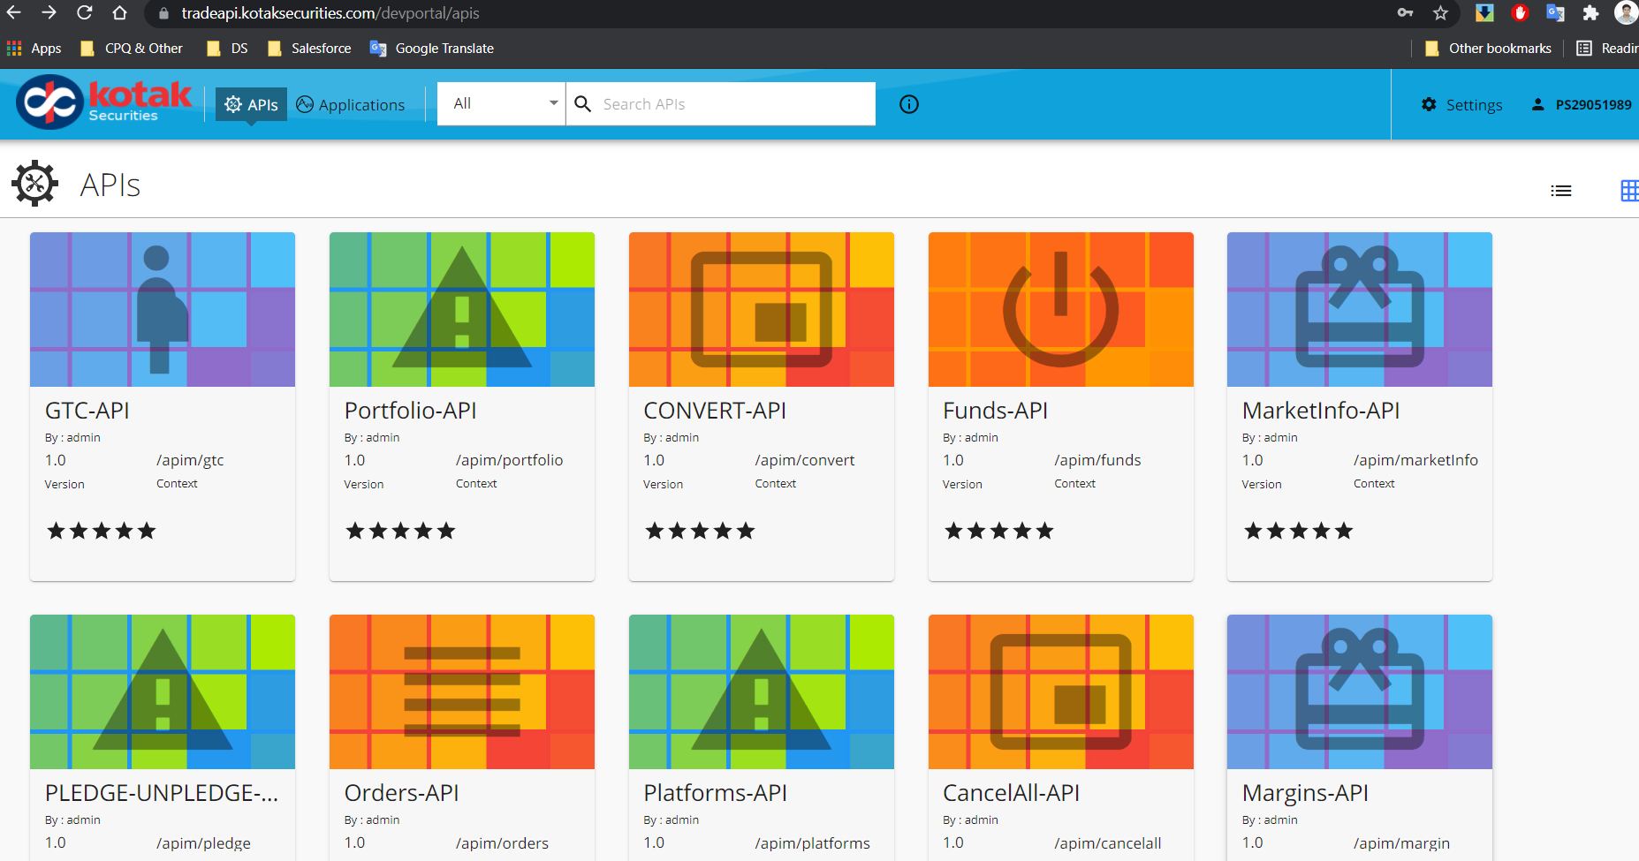
10. 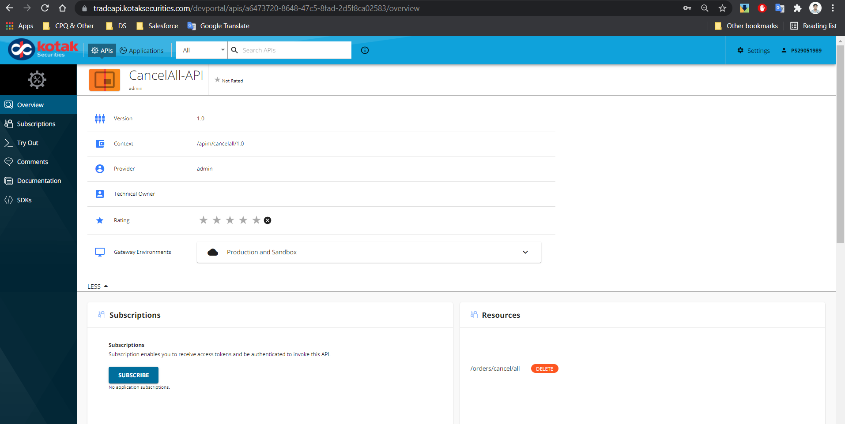
11. Subscribe to API to link your API to System API
12. Subscribe to all others it will take time so I already subscribed previously and that’s all
14. That the part finish for API.
15. After this Python part start
16. Go to Github <https://github.com/osparamatrix/ks-orderapi-python> from this link.
17. Open the CMD type pip install git+https://github.com/osparamatrix/ks-orderapi-python.git
18. If its give you the git hub error then you need to install the Github Bash from <https://git-scm.com/downloads>
19. After git install rerun the 19 step.
20. Open your IDE for python I prefer Spyder IDE "https://www.spyder-ide.org/"
21. Go to Console Run “import ks_api_client”
22. 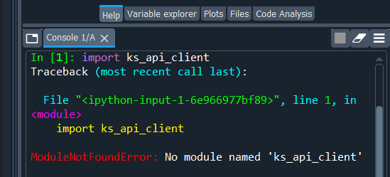
23. If you get ModuleNotFoundError: No module named 'ks_api_client' error then
24. Go to My Computer or this pc or C drive and search for the folder “ks_api_client” as git will install the kotak api in your default IDE in many case the IDE are python.
25. 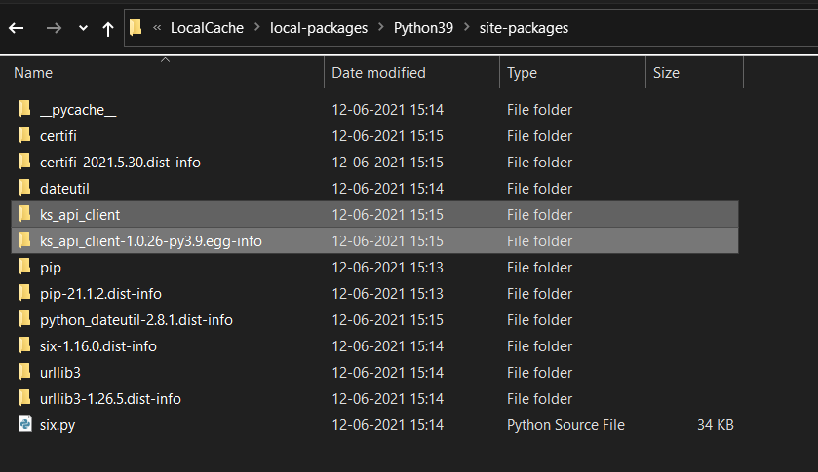
26. But in case you are using different IDE then 25 to 28 steps are imp.
27. Copy the 2 folders start with ks_ in your IDE local like C:\ProgramData\Anaconda3\Lib or C:\Users\prani\AppData\Roaming\Python\Python38\site-packages
28. 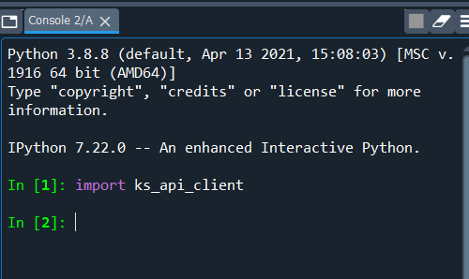
29. After doing step 29 rerun the step 23
30. Now we are going to login

Here your initial setup is completed, now go to github <https://github.com/RaigadTechnology/Kotak_API_Demo>

Get the Demo code & main code to start the trading.

In video I explain the all the steps to get the data.